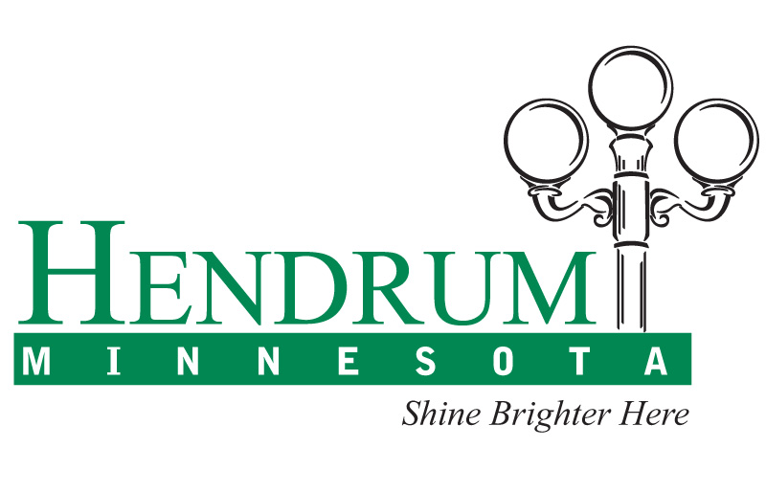

Building Incentives*

- 1st Lot Sold in the New Development for a $1.00

Regular sale price of $9,900.

- NO City Special Assessments in the New Development

- City Tax Abatement

House Assessed Value Tax Abatement

Over $150,000 $1,000 per year
$125,000 to $149,999 $ 700 per year
$100,000 to $124,999 $ 500 per year
$ 50,000 to $ 99,999 $ 300 per year

* Abatements will be made for a five-year term on the proposed property.

- 2 Years FREE City Utilities with Water & Sewer Connection Fees Waived.

Approximately a $2000.00 value.

- Electric Incentives

Red River Valley Co-op Power Assn. will waive the $250.00 connection fee. Many other energy saving resources, incentives, and rebates available. Please visit www.rrvcoop.com for more information.

- Cable & Phone Incentives

Loretel Systems will provide free installation of telephone, Internet, and cable ($95.00 value) with 3 months basic cable and 1-month high speed Internet free ($210.00 value).

- Nepstad Oil Company

For propane installed, 4 Years FREE propane tank rental ($60.00 per year value); new furnace and water heater rebates (subject to availability).

- Perley Community Co-op

Perley Community Co-op will offer 3 years of FREE propane tank rental ($45.00 - $80.00 per year value).

- Norman County Single Family Housing Fund Program

Available to qualified applicants. Please contact the City of Hendrum for further information.

*All incentives are subject to the qualifications and requirements of the City of Hendrum. Incentives only apply

to new home construction. First qualified applicant will receive full offer of reduced lot price. Other incentives still apply

for subsequent applicants. Limited time only. Other incentives may be available and are subject to change or end at any time.

Contact the City of Hendrum at (218) 861-6210 or visit www.HendrumMN.com for further information.

